**// Submitted by Jagadeesh Kumar . S**

**2. https medium.com_@reach2arunprakash_guvi-zen-class-find-the-culprits-and-nail- them-9ee6c67c44fb**

**Part:1 Find the culprits and nail them-debugging scripts.**

1. **Find the culprit.**

**Solution:** In the above code in the “alert” message there is only given single codes instead of double codes at the end.

<!DOCTYPE html>

<html>

<body>

<script>

alert( "I’m JavaScript!");

</script>

Whats the error in this ?

</body>

</html>

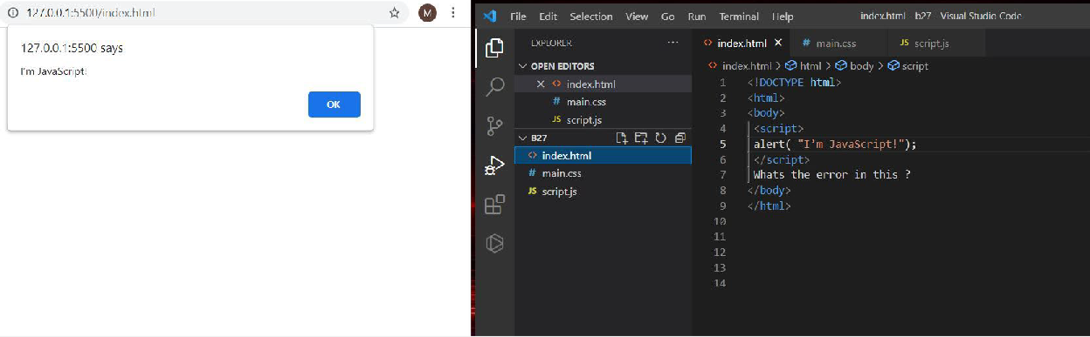

1. **Find the culprit and invoke the alert.**

Solution:

Fix.html

<!DOCTYPE html>

<html>

<body>

<script src="script.js"></script>

</body>

</html>

Script.js

alert("I'm invoked!");

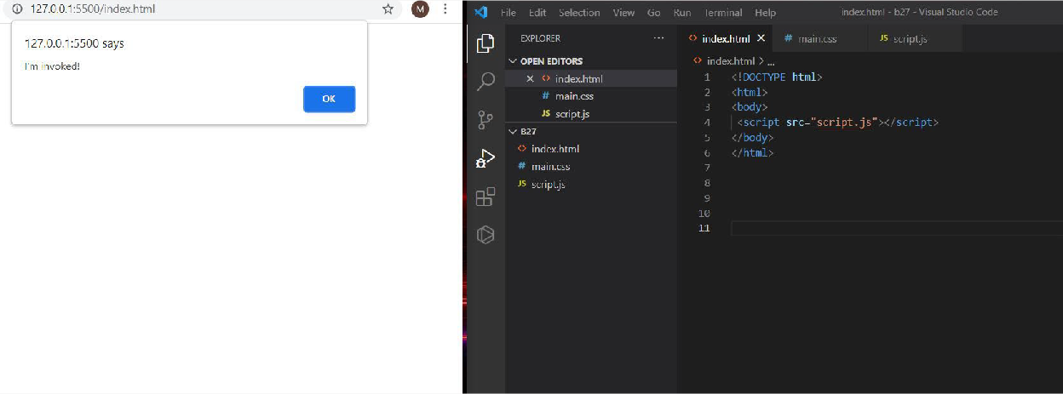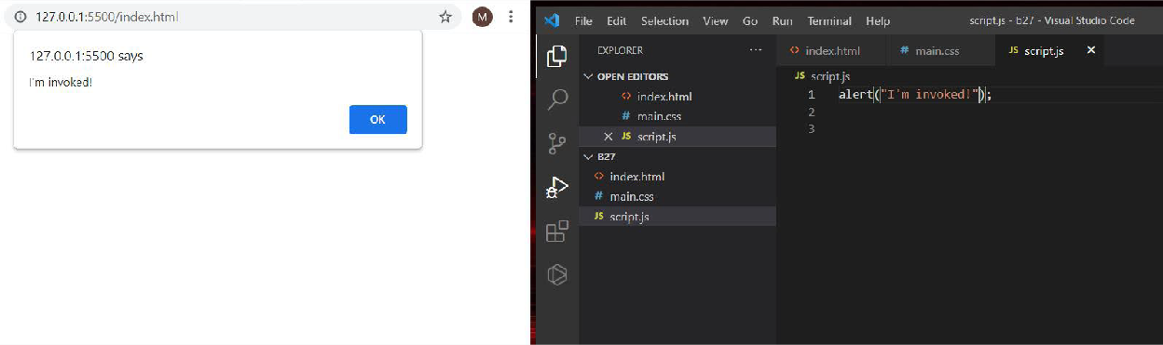

1. **Explain the below how it works.**

Solution:

explain.html

<!DOCTYPE html>

<html>

<body>

<script src="script.js"></script>

</body>

</html>

Script.js

alert("I'm JavaScript!");

alert('Hello') // this line is not having semicolon alert(`Wor

ld`) alert(3 +

1

+ 2); // this is multiple line code and its working

* First after giving the code and run we will get the first alert like “I’m Javascript” after clicking ok next message will appear i.e., ‘Hello’ in next ok (Wor) and a newline in alert message (ld) will appear and after clicking ok 6 will appear as alert.

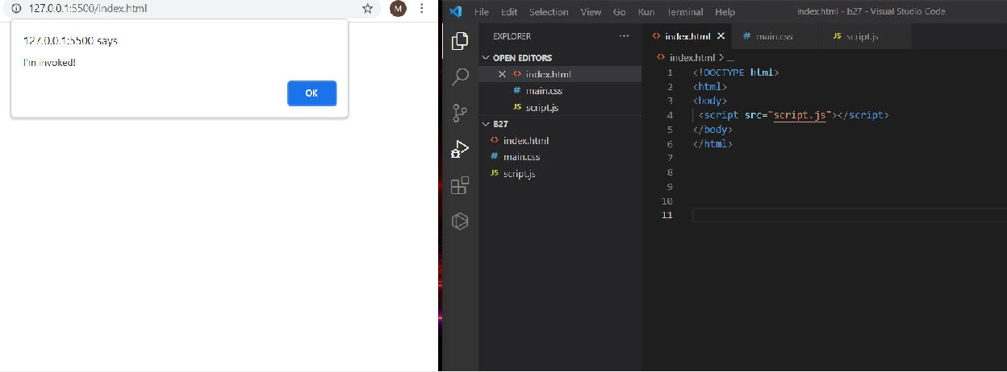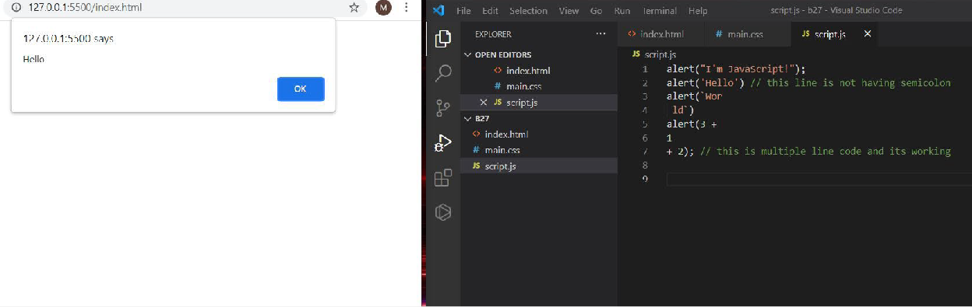

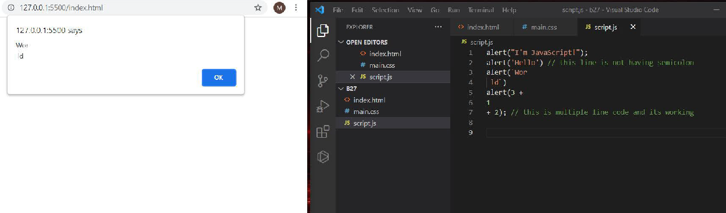

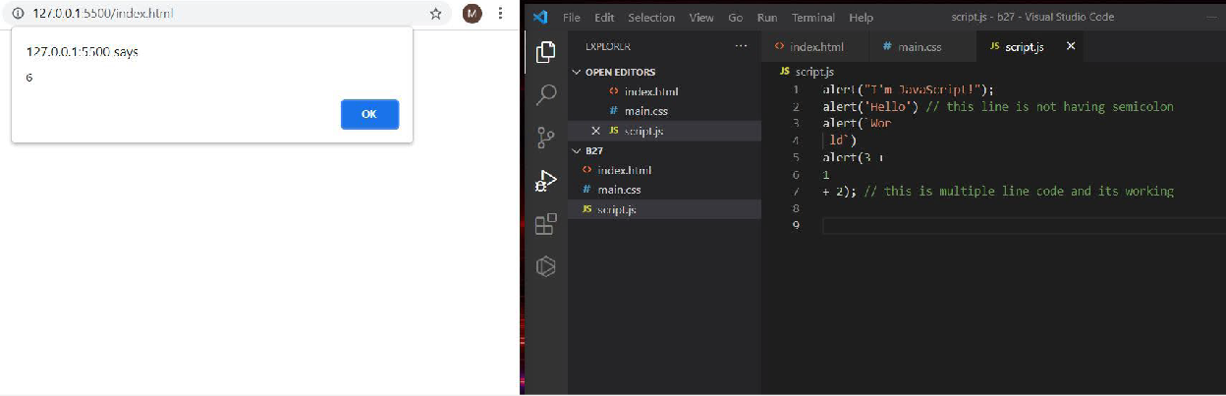

1. **Fix the below code to alert Guvi geek**

Solution:

fix.html

<!DOCTYPE html>

<html>

<body>

<script src="script.js"></script>

</body>

</html>

Script.js:

let admin=9, fname=10.5; fname = "Guvi";

lname = "geek";

admin = fname +" "+lname;

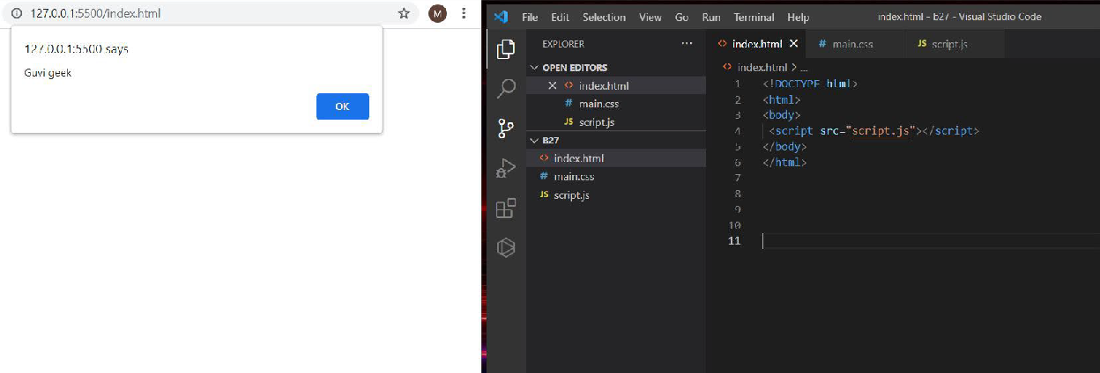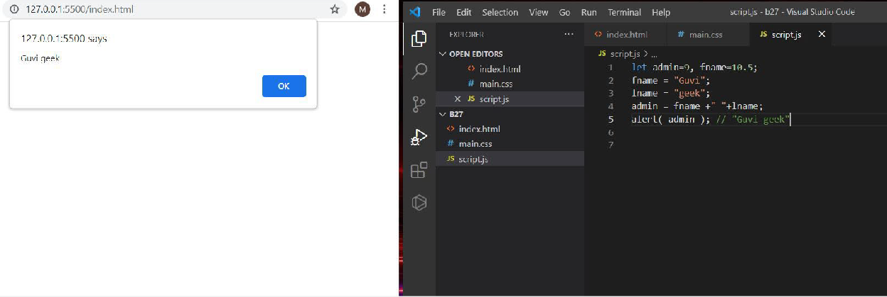alert( admin ); // "Guvi geek"

1. **Fix the below to alert hello Guvi geek**

Solution: fix.html

<!DOCTYPE html>

<html>

<body>

<script src="script.js"></script>

</body>

</html>

Script.js:

let fname=10.5; fname = "Guvi"; lname = "geek";

let name = fname+" "+lname; alert( `hello ${name}`);

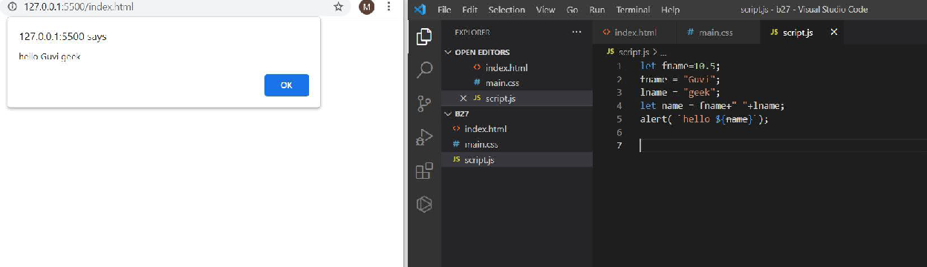

6,7. Fix the below to alert sum of two numbers

Solution:

fix.html

<!DOCTYPE html>

<html>

<body>

<script src="script.js"></script>

</body>

</html>

Script.js:

let a = +(prompt("First number?")); let b = +(prompt("Second number?")); alert(a + b);

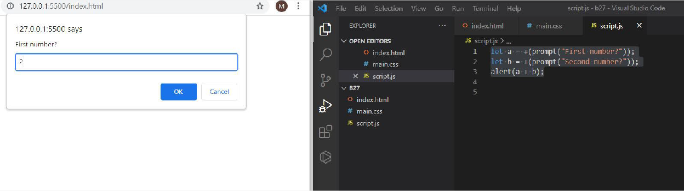

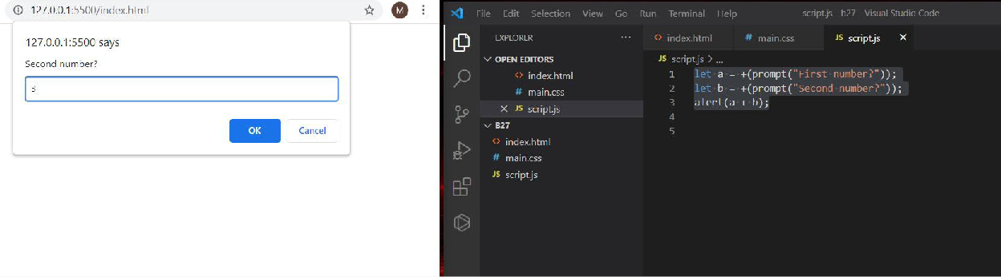

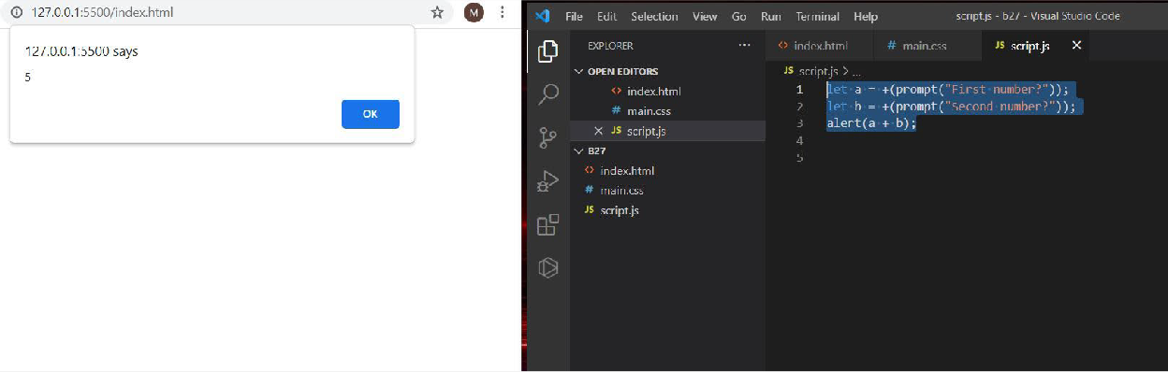

1. **If you run the below script you will get “**Code is Blasted**”**

Explain Why the Code is blasted and how to diffuse it and get “Diffused”.

Solution:

fix.html

<!DOCTYPE html>

<html>

<body>

<script src="script.js"></script>

</body>

</html>

**For code blasted:** In this based on the true and the false condition it will get the because we are comparing the strings.

Script.js:

var a = "2" > "12";

//Don't touch below this

if (a) {

console.log("Code is Blasted");

}

else

{

console.log("Diffused");

}

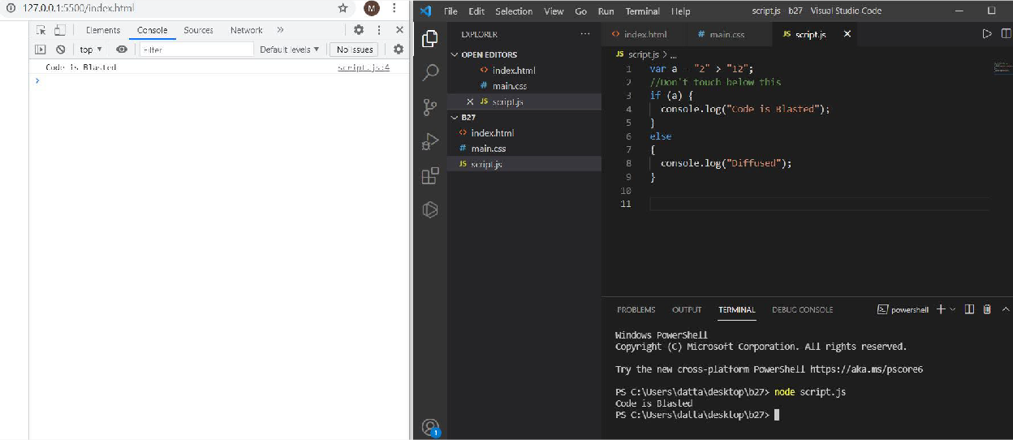

**For diffused:** In this it will check both the data and type if the condition then it will print the diffused.

var a = "2" === "12";

//Don't touch below this if (a) {

console.log("Code is Blasted");

}

else

{

console.log("Diffused");

}

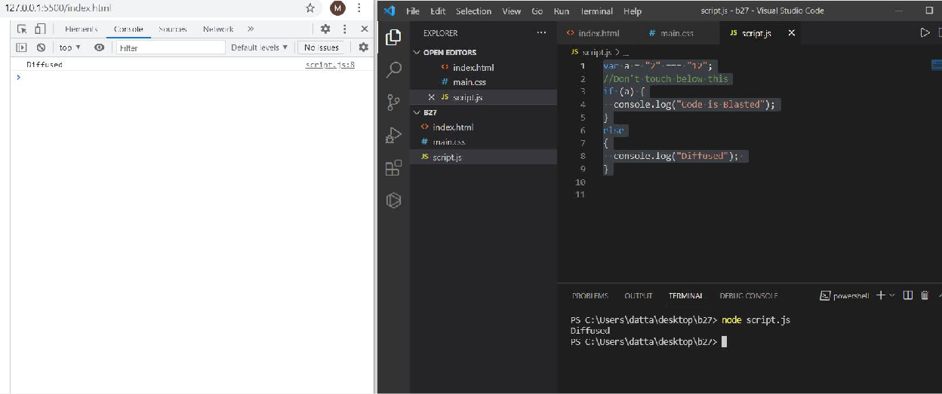

1. **How to get success in the console.**

**Solution:** If we are not given anything in the prompt message it will get success in the console.

fix.html

<!DOCTYPE html>

<html>

<body>

<script src="script.js"></script>

</body>

</html>

Script.js:

let a = prompt("Enter a number?");

//Don't modify any code below this if (a) {

console.log( 'OMG it works for any number inc 0' );

}

else

{

console.log( "Success" );

}

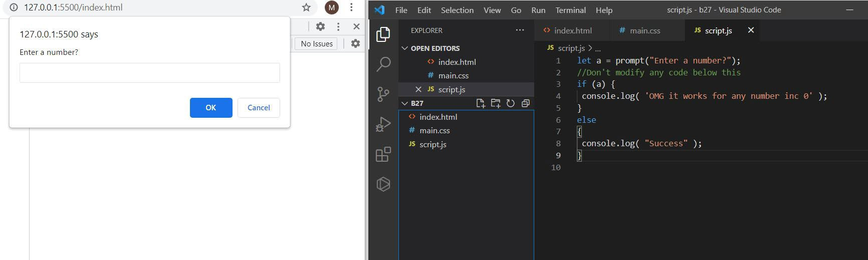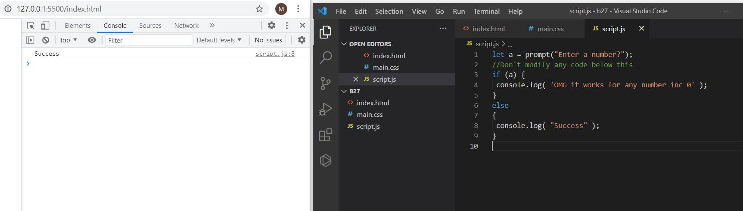

1. **How to get the correct score in the console.**

Solution: If we give the unary operator + before the prompt and typing the 4 or 6 when the prompt message is revealed it will get those respective messages in the console i.e, correct score if we give another it will show else condition message.

fix.html

<!DOCTYPE html>

<html>

<body>

<script src="script.js"></script>

</body>

</html>

Script.js:

let value = +(prompt('How many runs you scored in this ball')); if (value === 4) {

console.log("You hit a Four");

} else if (value === 6) {

console.log("You hit a Six");

} else {

console.log("I couldn't figure out");

}

|  |
| --- |
|  |
|  |
|  |
|  |

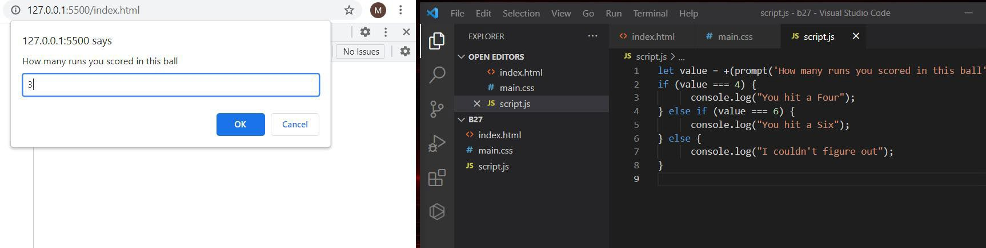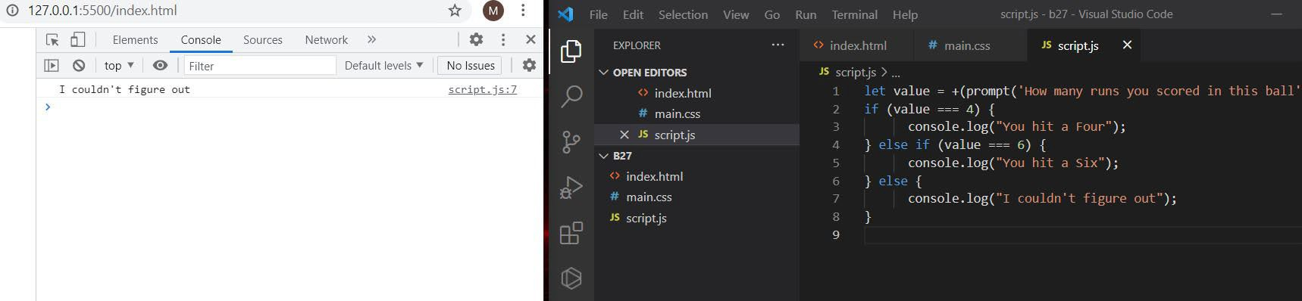

1. **Fix the code to welcome the Employee**

fix.html

<!DOCTYPE html>

<html>

<body>

<script src="script.js"></script>

</body>

</html>

Script.js:

let login = 'Employee';

let message = (login === 'Employee') ? "Welcome the employee": "nothing";

(login === 'Director') ? 'Greetings' :

(login === '') ? 'No login' :

'';

console.log(message);

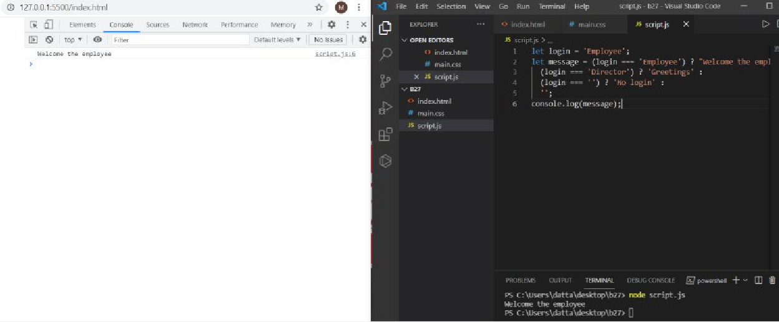

1. **Fix the code to welcome the boss solution:**

fix.html

<!DOCTYPE html>

<html>

<body>

<script src="script.js"></script>

</body>

</html>

Script.js:

// You cant change the value of the msg let message;

if (null || 2 || undefined )

**{**

message = "welcome boss";

**}**

else

**{**

message = "Go away";

**}**

console.log(message);

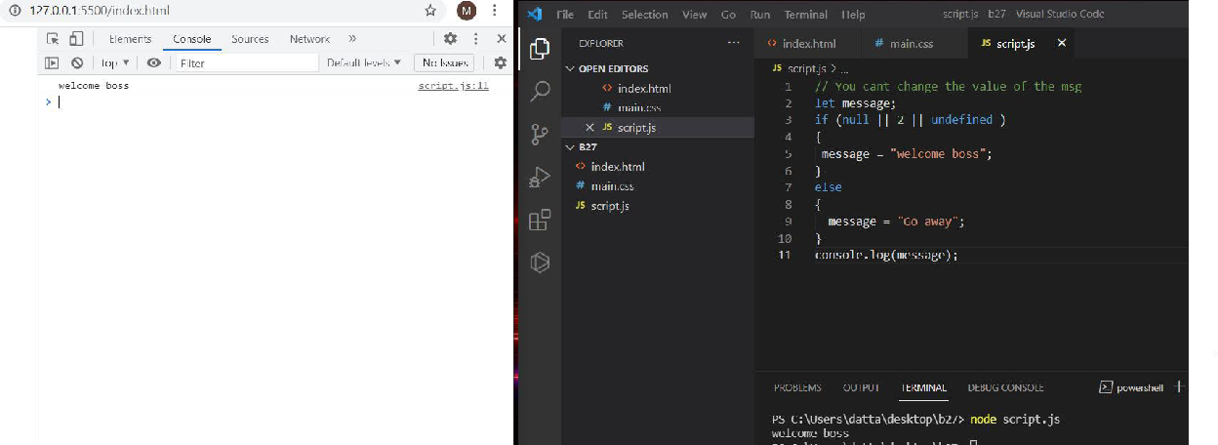

1. **Fix the code to welcome the boss solution:**

fix.html

<!DOCTYPE html>

<html>

<body>

<script src="script.js"></script>

</body>

</html>

Script.js:

let message; let lock;

//Dont change any code below this if (null || lock || undefined )

{

message = "Go away";

}

else

{

message = "welcome";

}

console.log(message);

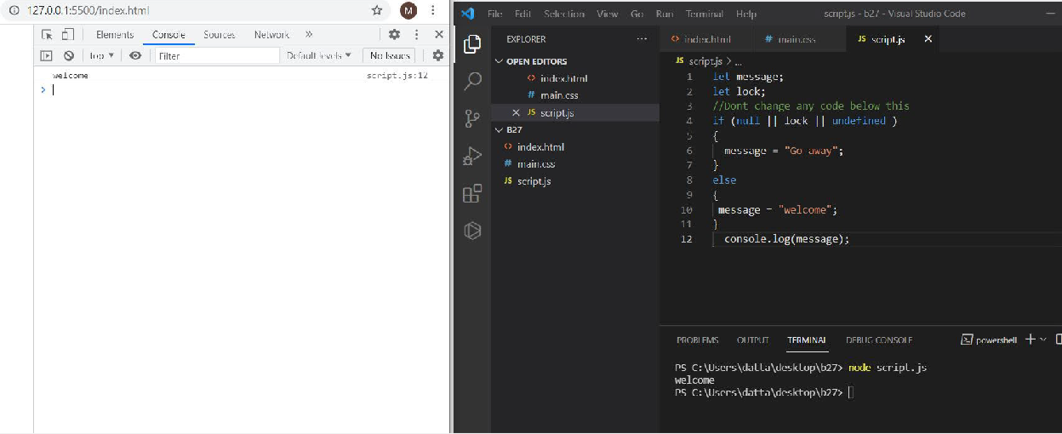

1. **13. Fix the code to welcome the boss solution:**

fix.html

<!DOCTYPE html>

<html>

<body>

<script src="script.js"></script>

</body>

</html>

Script.js:

let message; let lock ;

//Don't change any code below this if (lock && " " || undefined )

{

message = "Go away";

}

else

{

message = "welcome";

}

console.log(message);

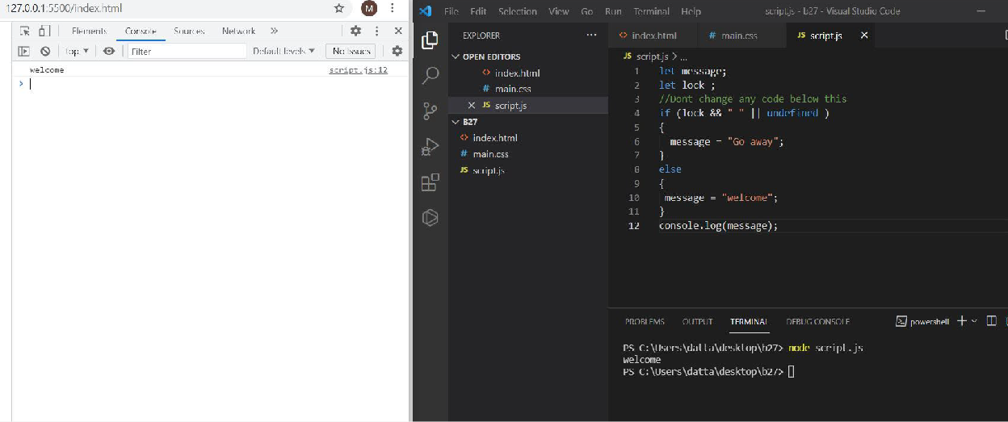

1. **Change the code to print 3**

2

1

solution:

fix.html

<!DOCTYPE html>

<html>

<body>

<script src="script.js"></script>

</body>

</html>

Script.js:

//You can change only 2 characters let i = 3;

while (i) {

console.log( i );

--i;

}

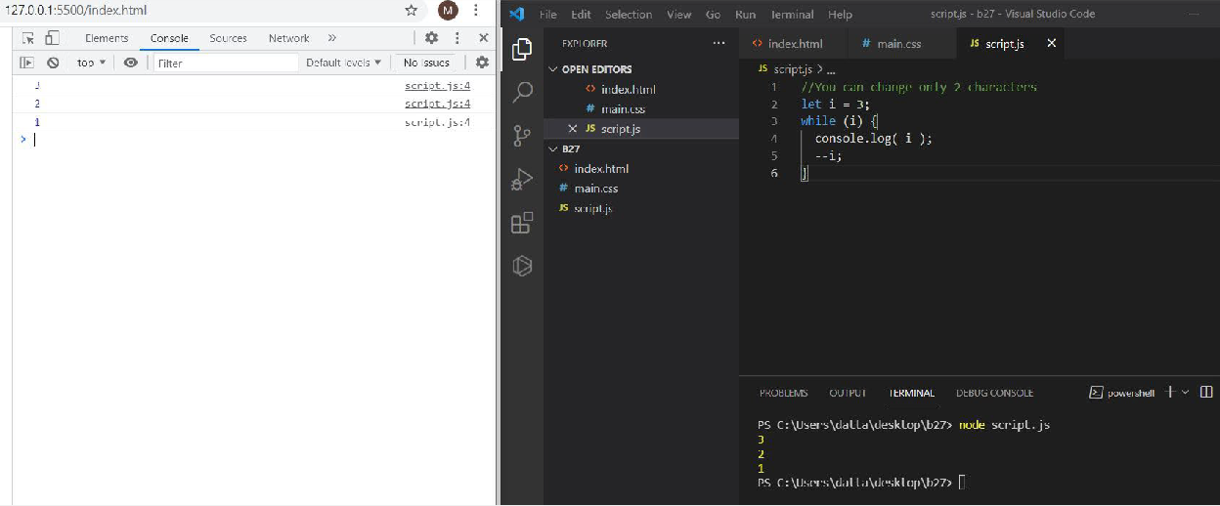

1. **Change the code to print 1 to 10 in 4 lines solution:**

fix.html

<!DOCTYPE html>

<html>

<body>

<script src="script.js"></script>

</body>

</html>

Script.js:

let num=3;

let newnum =""; for(i=1;i<=num;i++){

newnum+=i+" ";

}

console.log(newnum); let num1=5;

let newnum1 =""; for(i=4;i<=num1;i++){

newnum1+=i+" ";

}

console.log(newnum1); let num2=8;

let newnum2 =""; for(i=6;i<=num2;i++){

newnum2+=i+" ";

}

console.log(newnum2); let num3=10;

let newnum3 =""; for(i=9;i<=num3;i++){

newnum3+=i+" ";

}

console.log(newnum3);

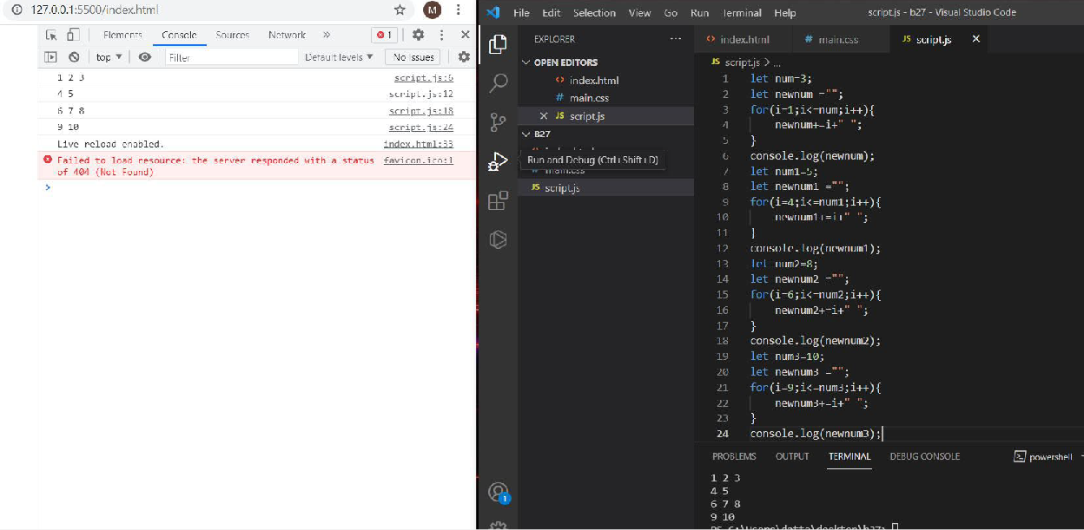

1. **Change the code to print even numbers solution:**

fix.html

<!DOCTYPE html>

<html>

<body>

<script src="script.js"></script>

</body>

</html>

Script.js:

//You are allowed to modify only one character for (let num = 2; num <= 20; num += 1) { if(num%2 === 0)

console.log(num);

}

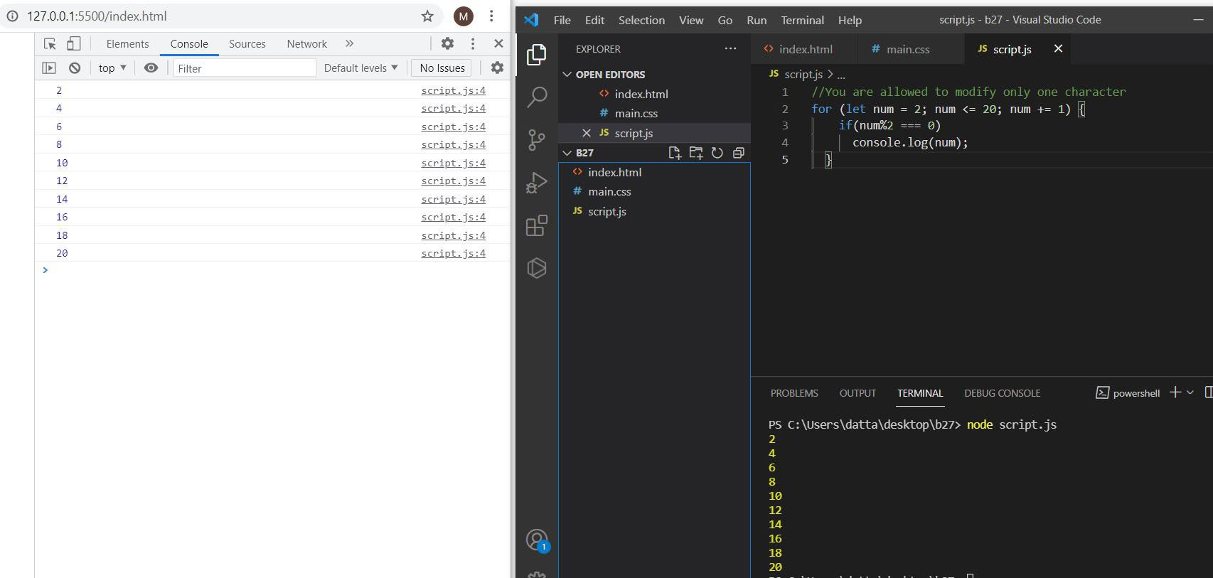

1. **Change the code to print all the gifts solution:**

fix.html

<!DOCTYPE html>

<html>

<body>

<script src="script.js"></script>

</body>

</html>

Script.js:

let gifts = ["teddy bear", "drone", "doll"]; for (let i = 0; i < 3; i++) {

console.log(`Wrapped ${gifts[i]} and added a bow!`);

}

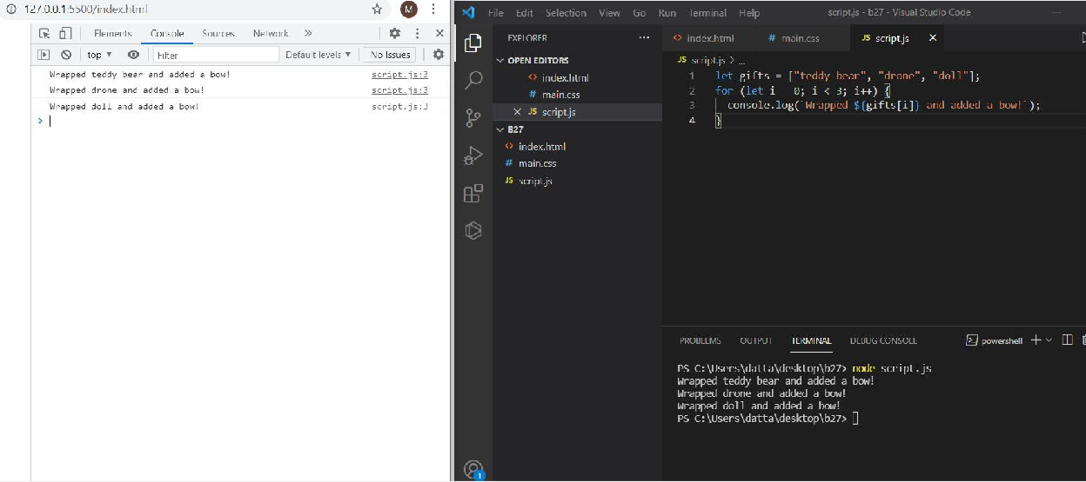

1. **Fix the code to disarm the bomb. solution:**

fix.html

<!DOCTYPE html>

<html>

<body>

<script src="script.js"></script>

</body>

</html>

Script.js:

let countdown = 100; while (countdown > 0) {

//countdown--;

if(countdown === 0)

{

console.log("bomb triggered");

}

countdown--;

}

console.log("disarm the bomb");

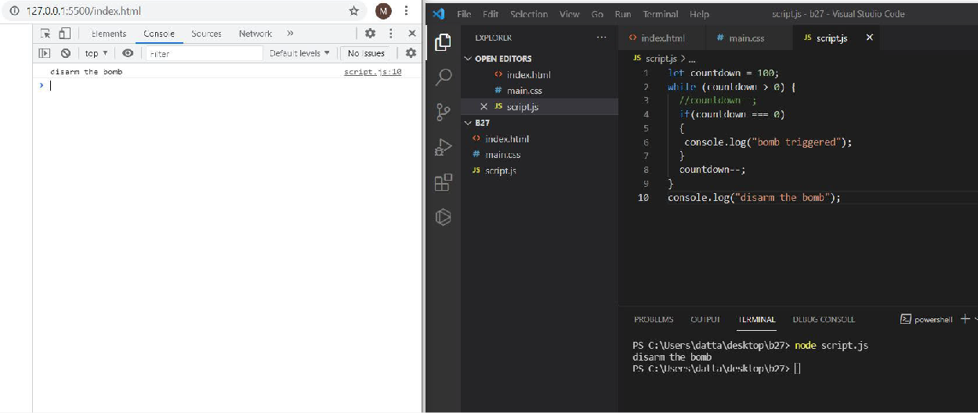

20,21. Whats the msg printed and why?

**Solution:** In this the hi message will printed because in the first if condition we have the condition is ok so will print that console output message.

fix.html

<!DOCTYPE html>

<html>

<body>

<script src="script.js"></script>

</body>

</html>

Script.js:

var lemein = "0"; var lemeout = 0; var msg = "";

if (lemein) { msg += "hi";

}

if (lemeout) { msg += 'Hello';

}

console.log(msg);

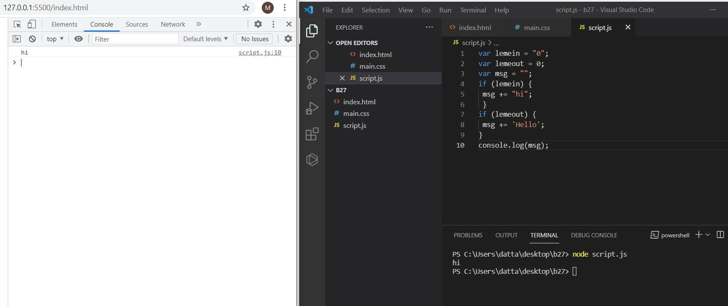

**3. https medium.com_@reach2arunprakash_www-guvi-io-zen-4fa483a7d359**

**Part:2 Find the culprits and nail them-debugging script loops.**

1. **Write a code to print the numbers in the array Output: 1234567891011**

Solution:

var numsArr = [ 1, 2, 3, 4, 5, 6, 7, 8, 9, 10, 11];

var new_string = "";

for (var i = 0; i < 11; i++) { new_string += numsArr[i];

**}**

console.log(new_string);

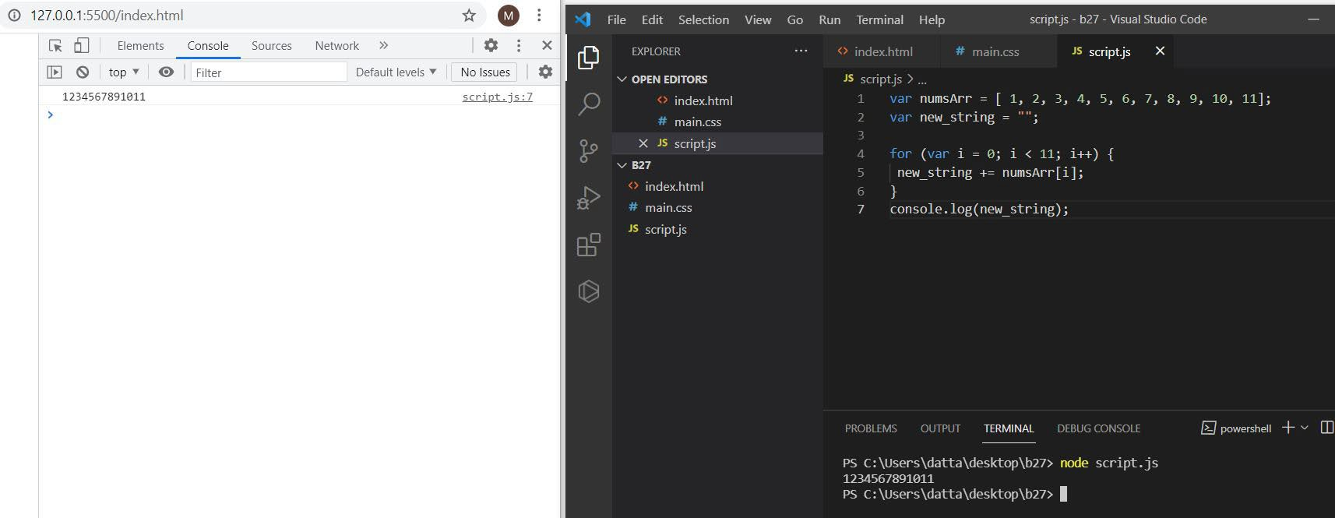

1. **Write a code to print the numbers in the array Output: 1,2,3,4,5,6,7,8,9,10,11**

Solution:

var numsArr = [ 1, 2, 3, 4, 5, 6, 7, 8, 9, 10, 11];

var new_string = "";

for (var i = 0; i < 11; i++) { new_string += numsArr[i] + ",";

**}**

console.log(new_string.slice(0,-1));

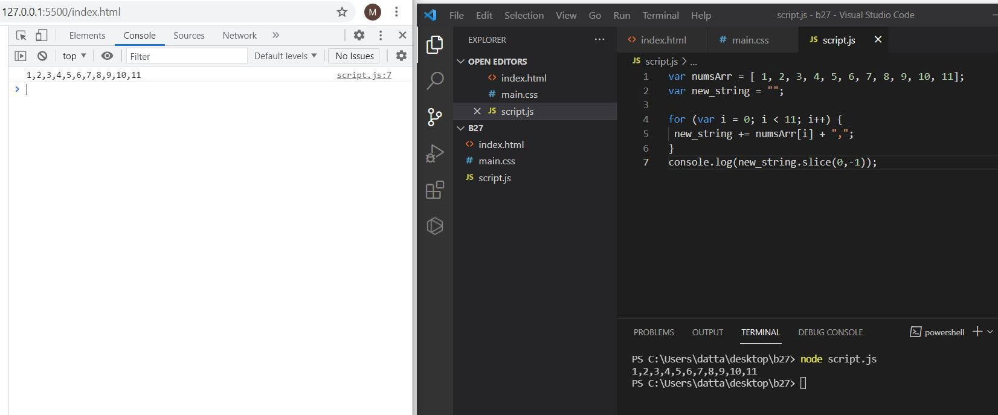

1. **Write a code to print from last to first with spaces (Make sure there is no space after the last element 1)**

Output: 11 10 9 8 7 6 5 4 3 2 1

Solution:

var numsArr = [ 1, 2, 3, 4, 5, 6, 7, 8, 9, 10, 11];

var new_string ="";

for (var i = 10; i >= 0; i-- ) { new_string += numsArr[i] + " ";

**}**

console.log(new_string.slice(0,-1));

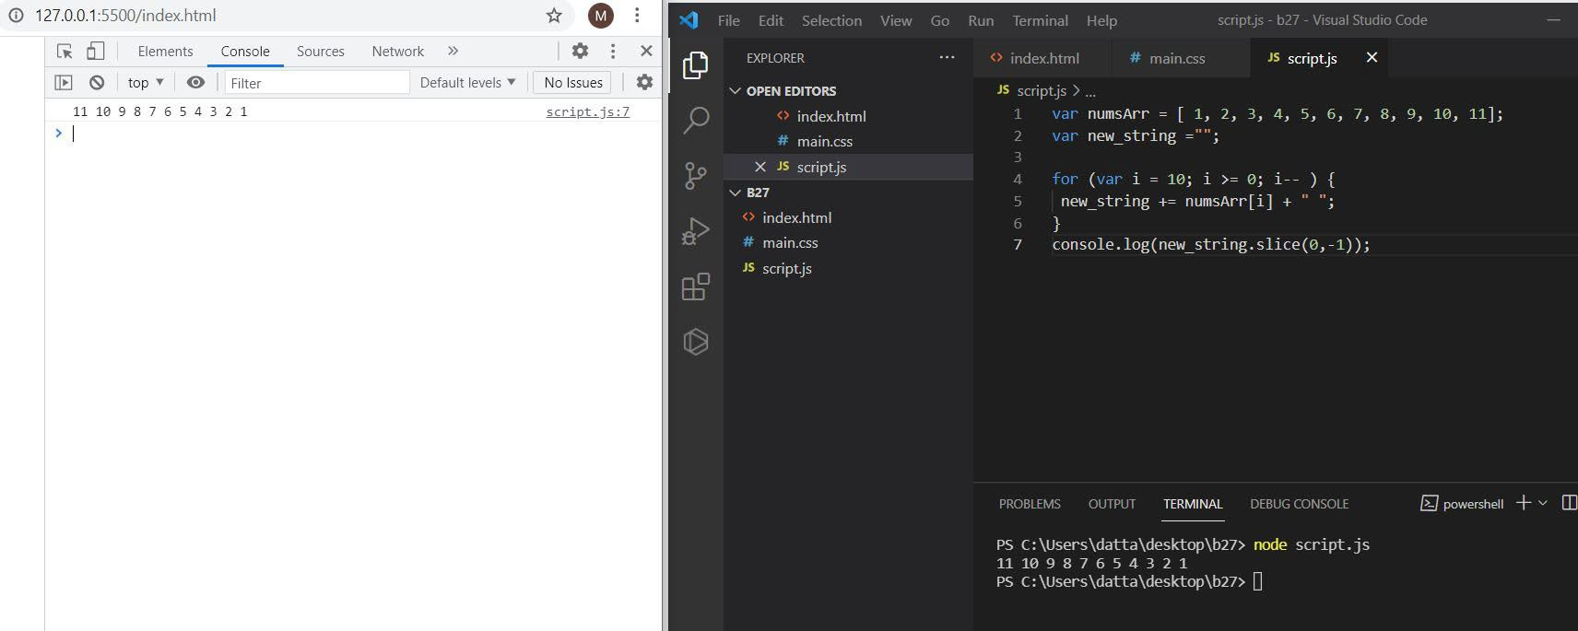

1. **Write a code to replace the array value — If the number is even, replace it with ‘even’.**

Output:[ 1, “even”, 3, “even”, 5, “even”, 7, “even”, 9, “even”, … ]

Solution:

var numsArr = [ 1, 2, 3, 4, 5, 6, 7, 8, 9, 10, 11];

for (var i = 0; i <=10; i++) { if(numsArr[i] %2 === 0 )

**{**

numsArr[i] = "even";

**}**

**}**

console.log(numsArr);

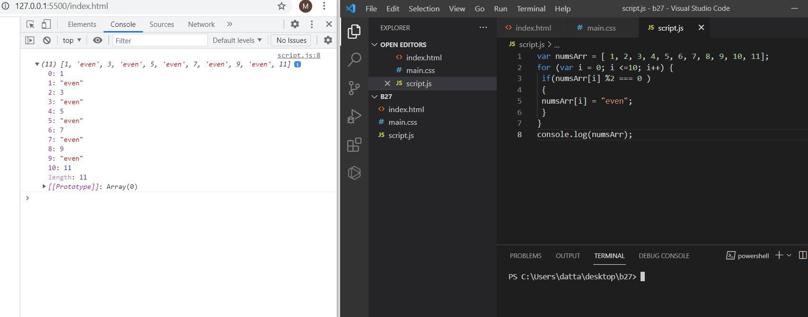

1. **Write a code to replace the array value — If the index is even, replace it with ‘even’.**

Output: [ “even”, 2, “even”, 4, “even”, 6, “even”, 8, “even”, 10, …]

Solution:

var numsArr = [ 1, 2, 3, 4, 5, 6, 7, 8, 9, 10, 11];

for (var i = 0; i <=10; i++) { if(numsArr[i] %2 !== 0 )

**{**

numsArr[i] = "even";

**}**

**}**

console.log(numsArr);

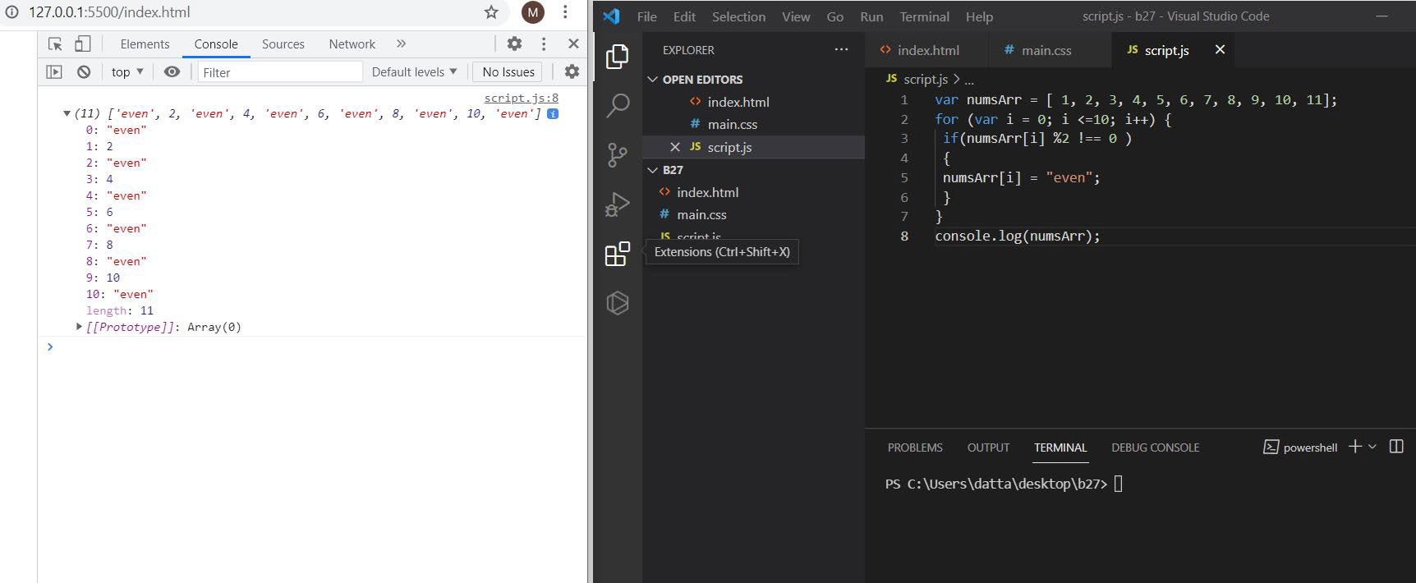

1. **Write a code to add all the numbers in the array Output: 66**

Solution:

var numsArr = [ 1, 2, 3, 4, 5, 6, 7, 8, 9, 10, 11];

var sum = 0;

for (var i = 0; i <=10; i++) { sum += numsArr[i];

**}**

console.log(sum);

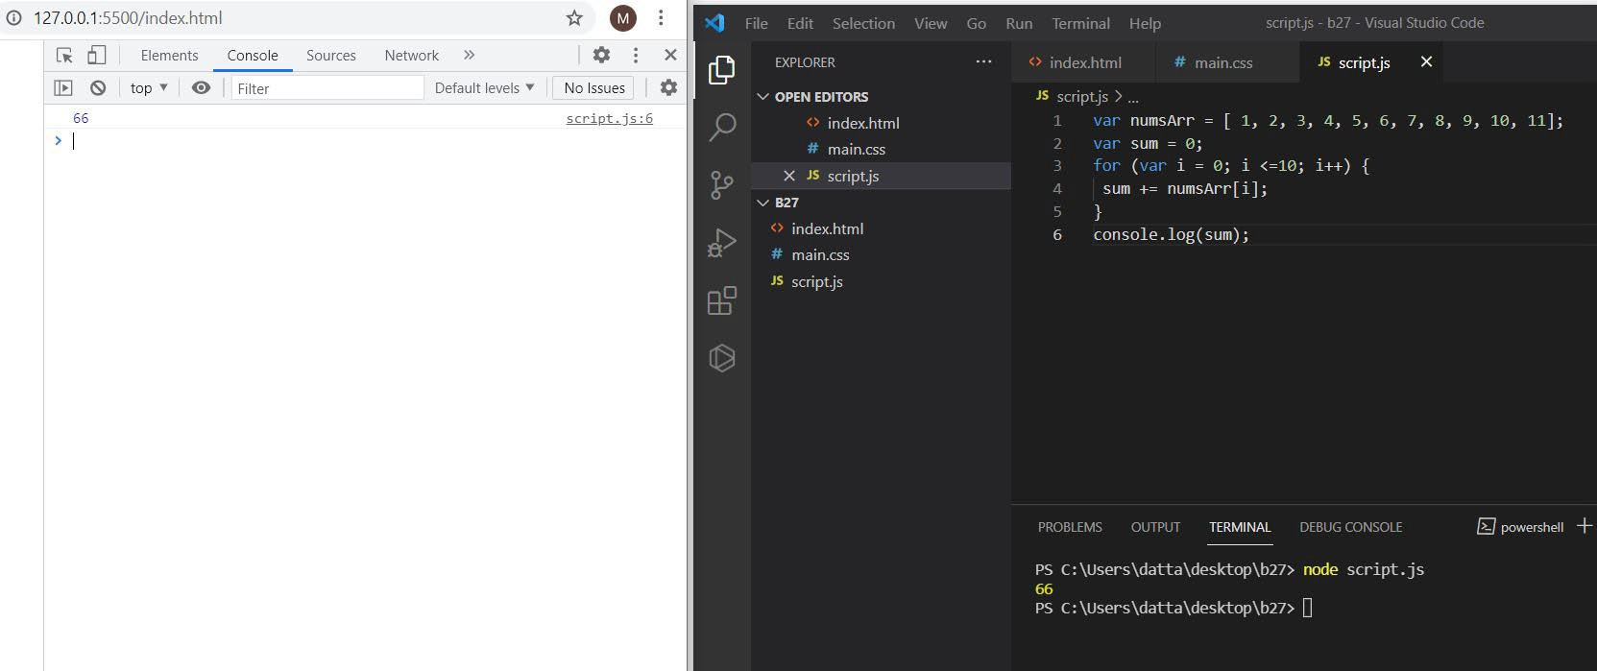

1. **Write a code to add the even numbers only Output: 30**

Solution:

var numsArr = [ 1, 2, 3, 4, 5, 6, 7, 8, 9, 10, 11];

var sum=0;

for (var i = 0; i <10; i++) { if(numsArr[i]%2===0){

sum += numsArr[i];

**}**

**}**

console.log(sum);

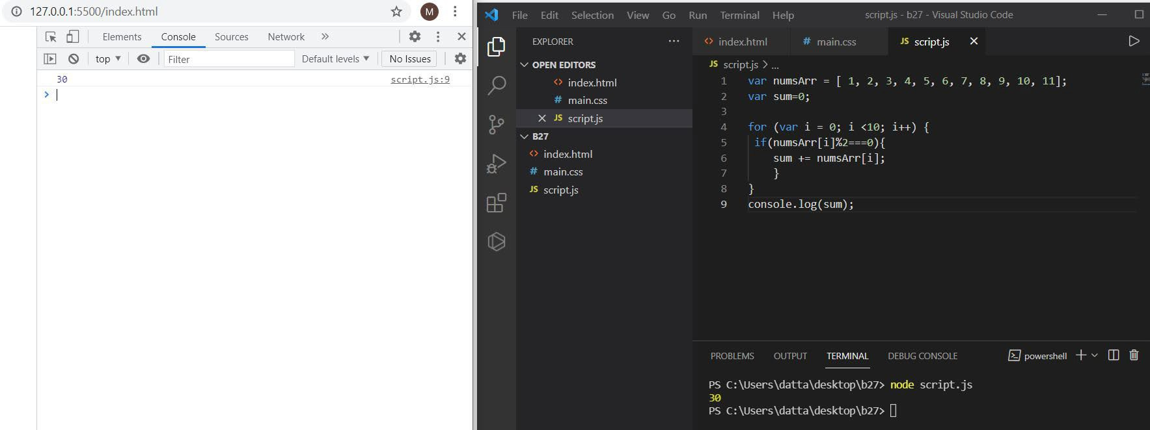

1. **Write a code to add the even numbers and subtract the odd numbers Output: 94**

Solution:

var numsArr = [ 1, 2, 3, 4, 5, 6, 7, 8, 9, 10, 11];

var sum=100;

for (var i = 0; i <=10; i++) { if(numsArr[i]%2===0)

**{**

sum += numsArr[i];

**}**

else

**{**

sum -= numsArr[i];

**}**

**}**

console.log(sum);

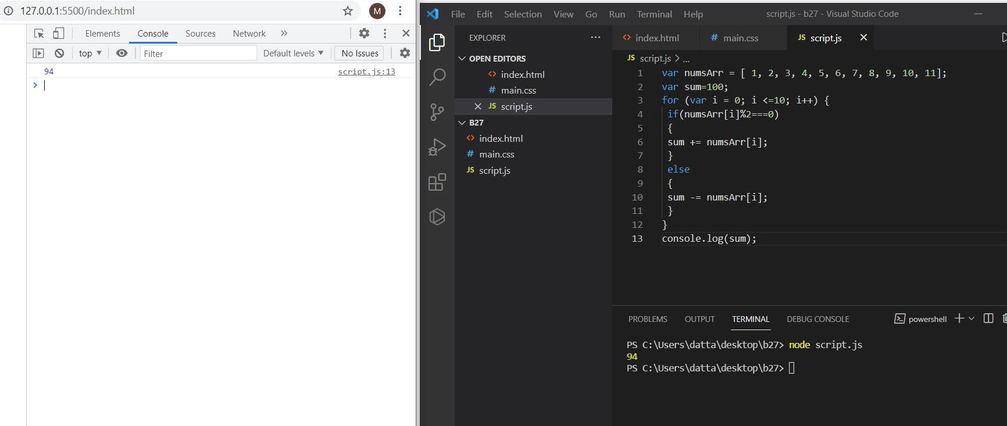

1. **Write a code to print inner arrays Output:Array(5) [ 1, 2, 3, 4, 5 ]**

Array(6) [ 6, 7, 8, 9, 10, 11 ]

Solution:

var numsArr = [[1, 2, 3, 4, 5],[ 6, 7, 8, 9, 10, 11]];

for (var i = 0; i < numsArr.length; i++){ console.log( numsArr[i]);

**}**

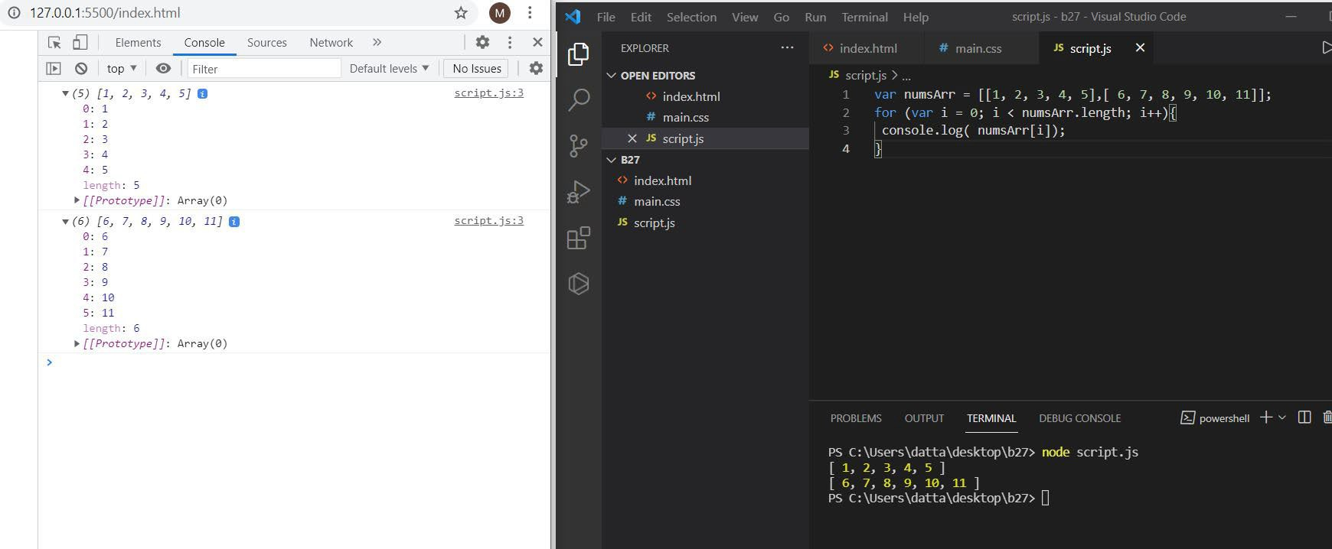

1. **Write a code to print elements in the inner arrays Output: 1234567891011**

Solution:

var numsArr = [[1, 2, 3, 4, 5],[ 6, 7, 8, 9, 10, 11]];

var str_all=[];

for (var i = 0; i < numsArr.length; i++) { var inner_array = numsArr[i];

for(var j = 0 ; j < inner_array.length;j++ ) str_all +=inner_array[j];

**}**

console.log(str_all);

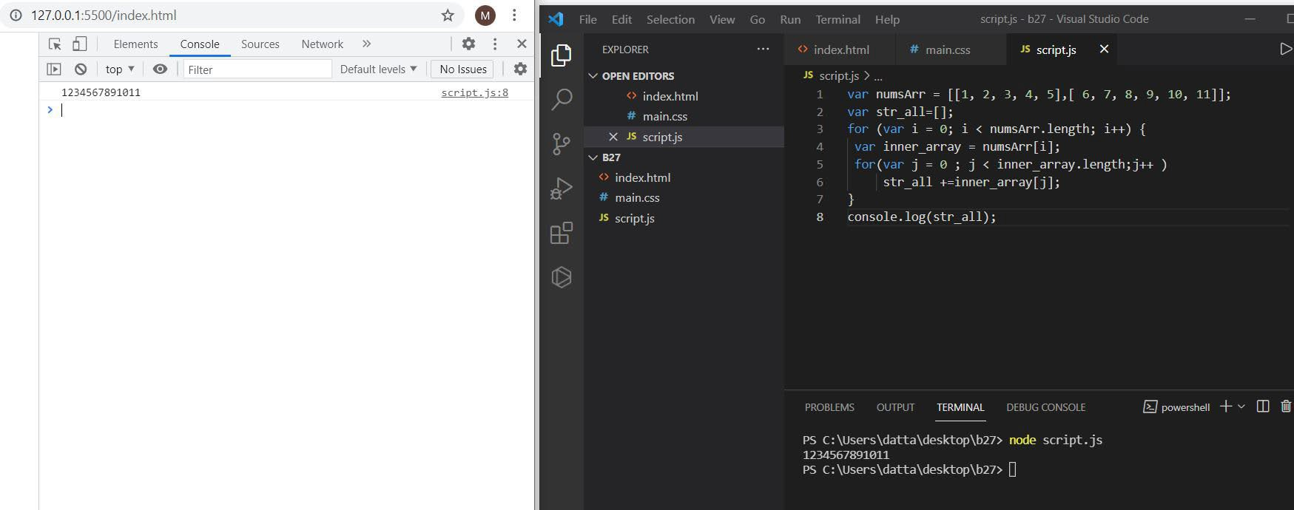

1. **Write a code to replace the array value — If the index is even, replace it with ‘even’.**

Output: [ [“even”, 2, “even”, 4, “even”], [6, “even”, 8, “even”, 10, …] ]

Solution:

var numsArr = [[1, 2, 3, 4, 5],[ 6, 7, 8, 9, 10, 11]];

for (var i = 0; i < numsArr.length; i++) { var inner_array = numsArr[i];

for(var j = 0 ; j < inner_array.length;j++ ) if(inner_array[j] %2 !== 0 )

**{**

inner_array[j] = "even";

**}**

**}**

console.log(numsArr);

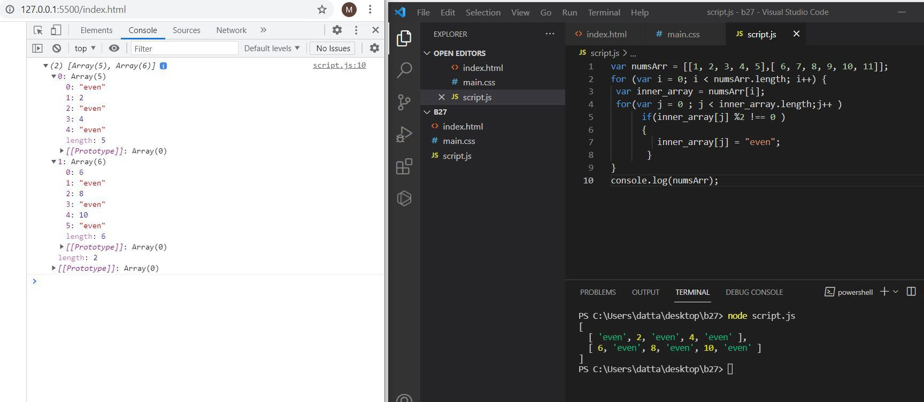

1. **Write a code to print elements in the inner arrays in reverse Output: 11 10 9 8 7 6 5 4 3 2 1**

Solution:

var numsArr = [[1, 2, 3, 4, 5],[ 6, 7, 8, 9, 10, 11]];

var str_all="";

for (var i = numsArr.length-1; i>=0; i--) { var inner_array = numsArr[i];

for(var j = inner_array.length-1; j >= 0 ;j-- ) str_all +=inner_array[j] + " ";

**}**

console.log(str_all);

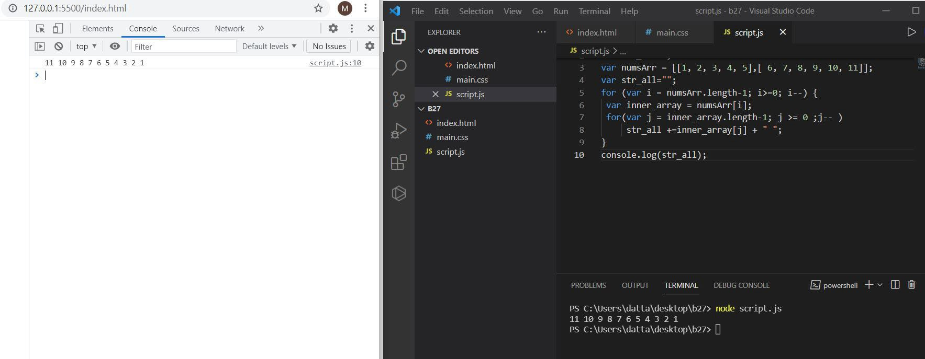

1. **Write a code to add elements in the inner arrays based on odd or even values**

Output:

36

30

Solution:

var numsArr = [[1, 2, 3, 4, 5],[ 6, 7, 8, 9, 10, 11]];

var sum_odd=0; var sum_even=0;

for (var i = 0; i < numsArr.length; i++) { var inner_array = numsArr[i];

for(var j = 0 ; j < inner_array.length;j++ ){ if(inner_array[j]%2!==0)

**{**

sum_odd += inner_array[j];

**}**

else

**{**

sum_even += inner_array[j];

**}**

**}**

**}**

console.log(sum_odd); console.log(sum_even);

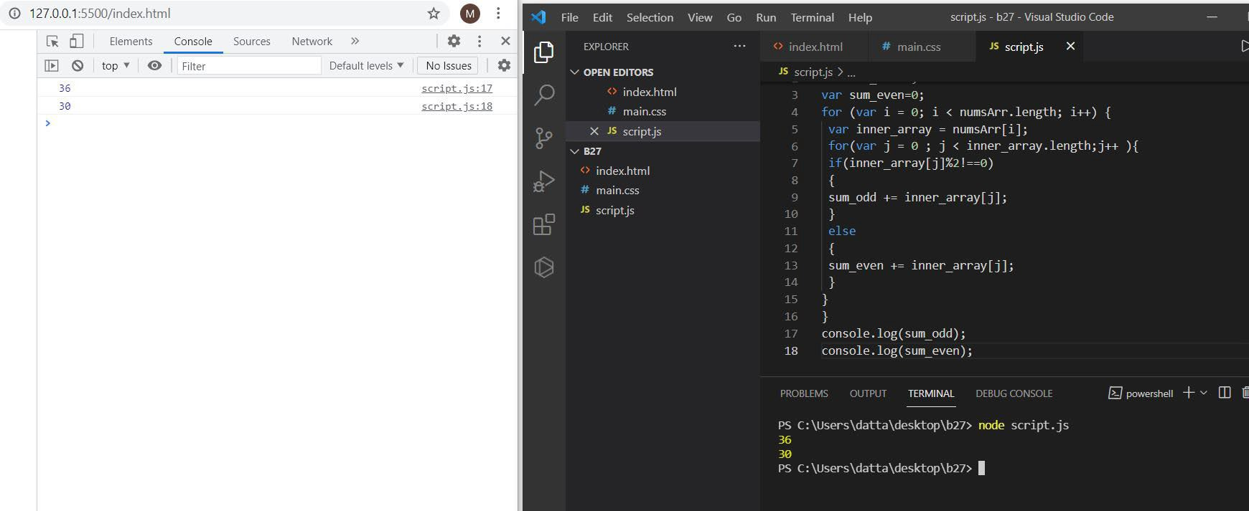

**4. https medium.com_@reach2arunprakash_guvi-zen-simple-debugging-tasks- adcdc2d3249d**

**Part:3 Find the culprits and nail them-debugging javascript.**

1. **Fix the code to get the largest of three.**

**let aa = (f,s,t) => {**

**if(f>s &&f>t){ console.log(f)} else if(s>f && s>t){ console.log(s)} else{ console.log(t)}**

**} aa(1,2,3);**

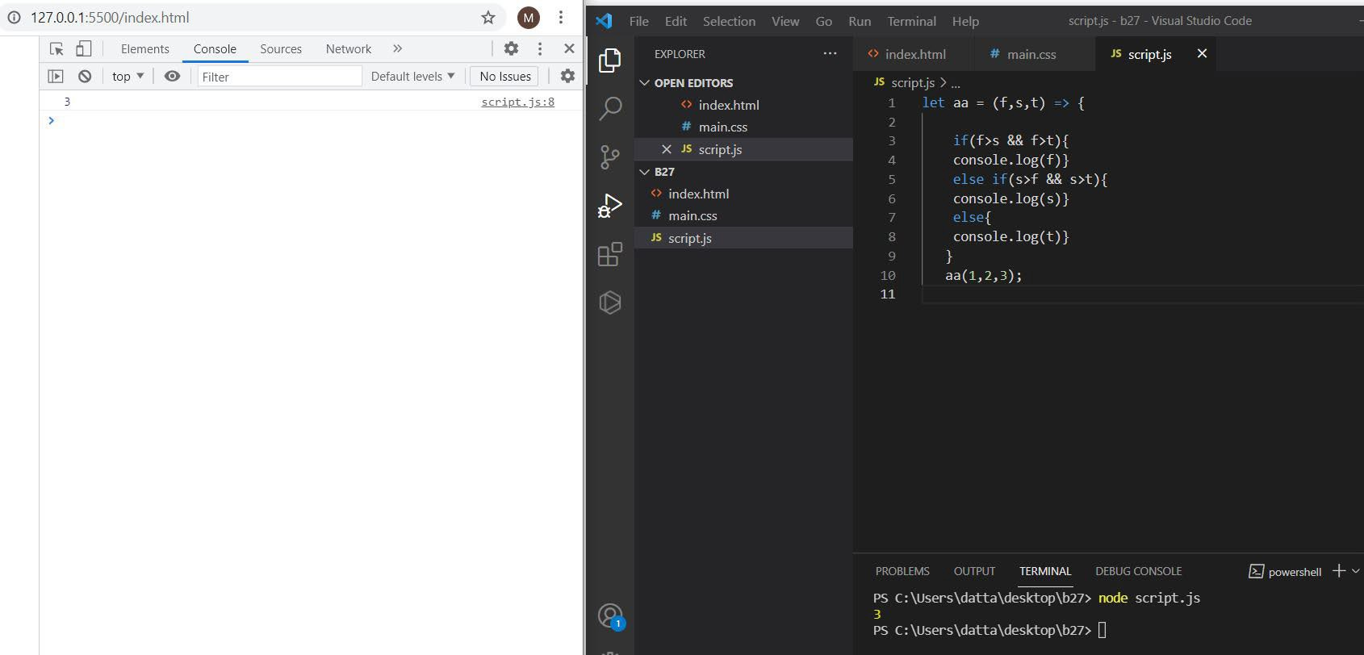

1. **Fix the code to Sum of the digits present in the number**

**let n = 123; console.log(add(n)); function add(n)**

**{**

**let sum ;**

**for(sum = 0; n > 0; sum += n % 10,**

**n = parseInt(n / 10));**

**return sum;**

**}**

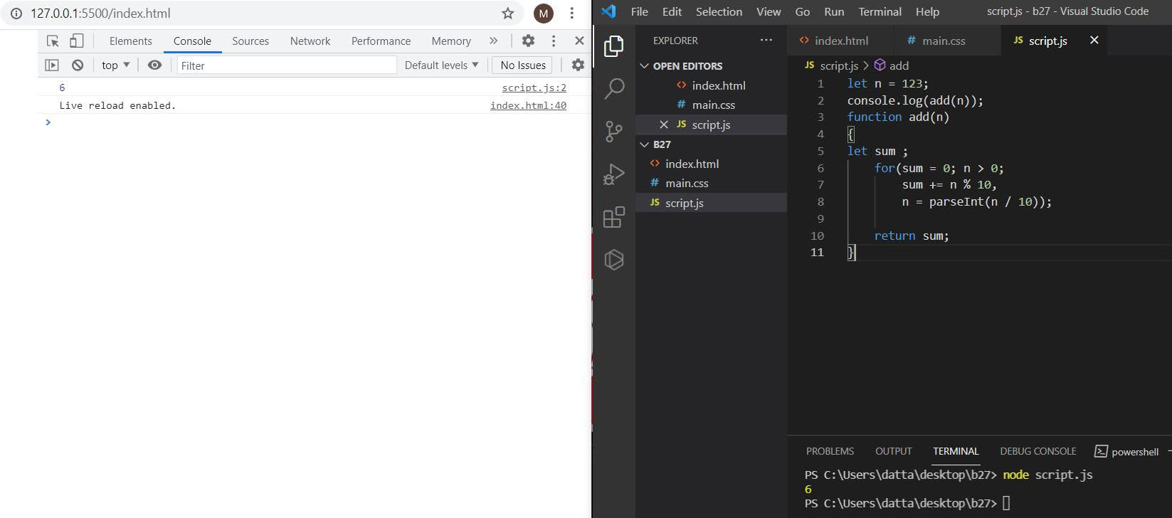

1. **Fix the code to Sum of all numbers using IIFE function**

const arr = [9,8,5,6,4,3,2,1];

(function() { let sum = 0;

for (var i = 0; i < arr.length; i++){ sum += arr[i];

**}**

console.log(sum); return sum;

**})();**

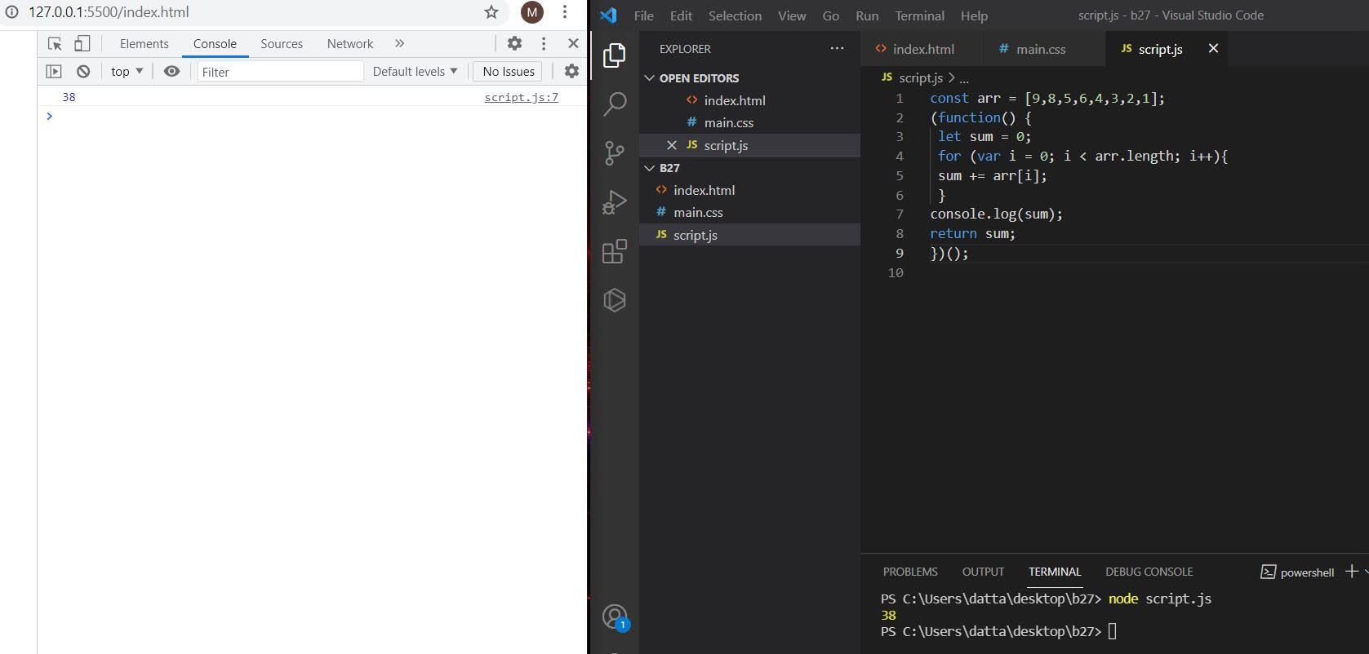

1. **Fix the code to gen Title case.**

# All first letters in title case.

var arr = ["guvi", "geek", "zen", "fullstack"]; var ano = function() {

for (var i = 0; i < arr.length; i++) { console.log(arr[i][0].toUpperCase() + arr[i].substr(1));

**}**

**};**

ano();

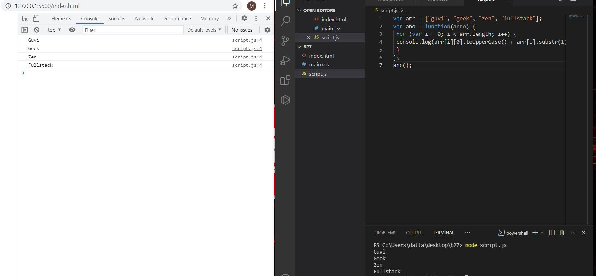

1. **Fix the code to return the Prime numbers**

const newArray=[1,3,2,5,10];

const myPrime=newArray.filter(num=>{ for(let i=2;i<=Math.sqrt(num);i++){

if(num%i===0)

**{**

return false;

**}**

else{

return true

**}**

**}**

return num!==1;

**});**

console.log(myPrime);

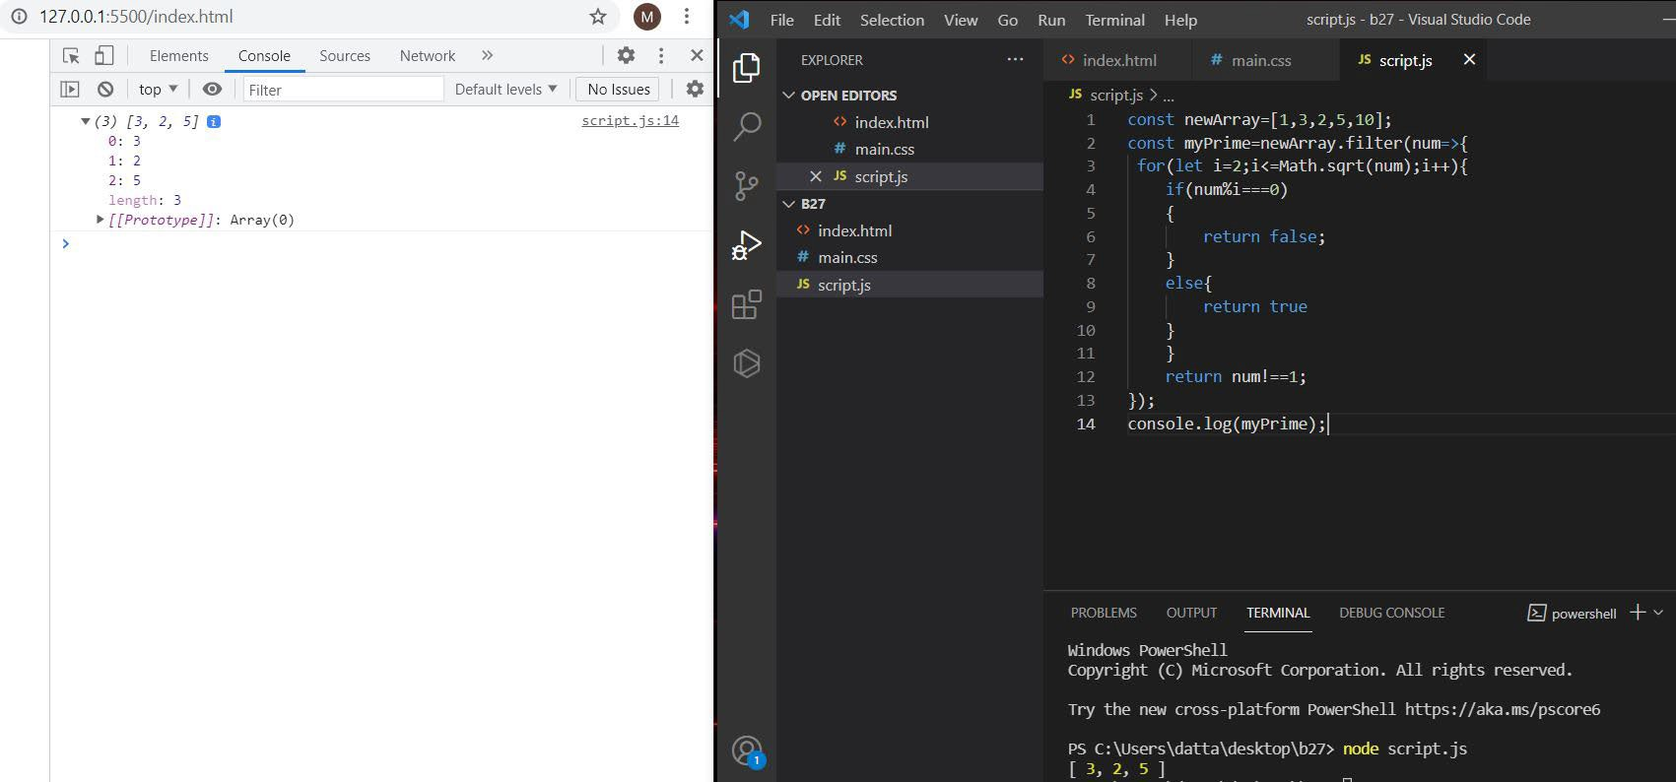

1. **Fix the code to sum the number in that array**

const num = [10, 20, 30, 40,50,60,70,80,90,100]

const sum = (a, b) => a + b

const newsum = num.reduce(sum) console.log(newsum);

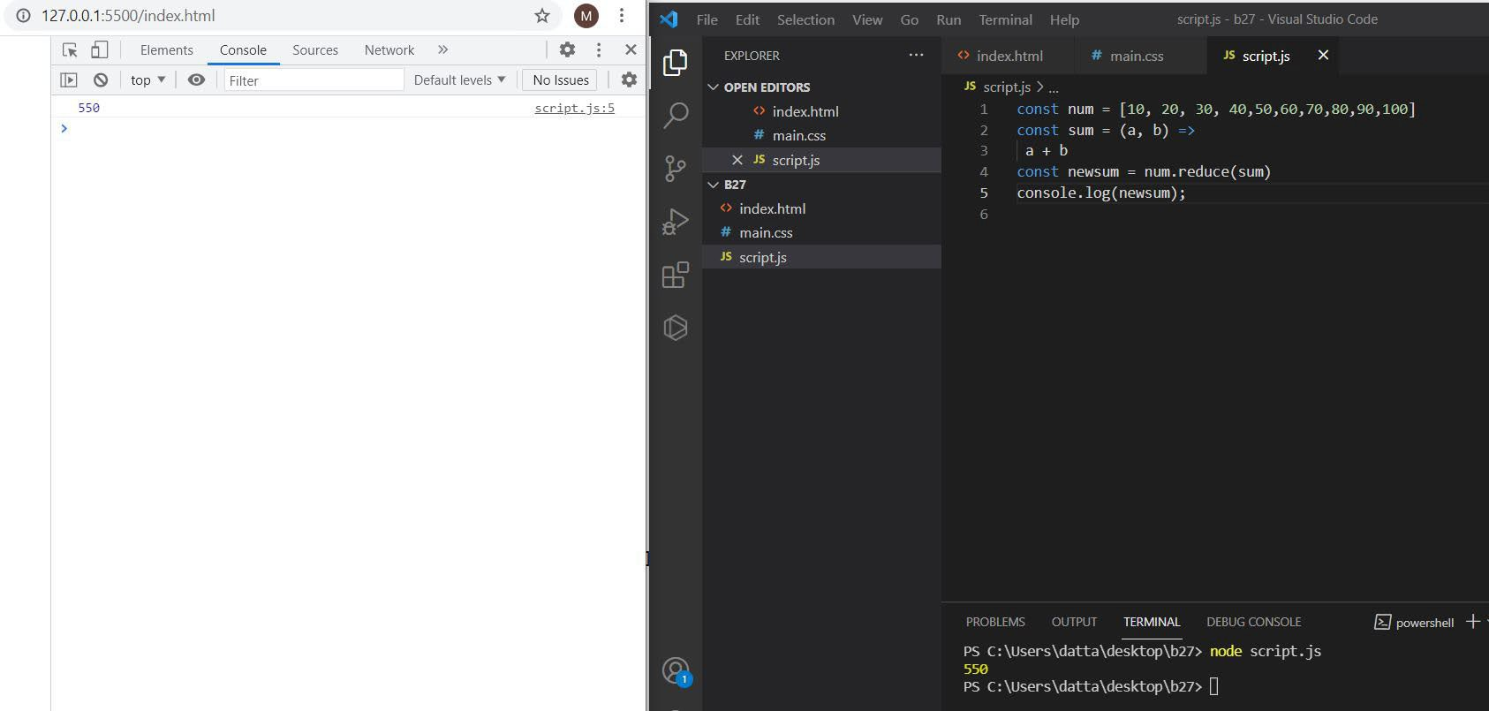

1. **Fix the code to rotate an array by k times and return rotated array using IIFE function**

var arr = [1, 2, 3, 6, 8, 6, 1, 9, 10, 12, 13];

var k = 3;

k = arr.length % k; (function(out) {

for (var i = 0; i < k + 1; i++) { arr.unshift(arr.pop());

**}**

console.log(out);

})(arr);

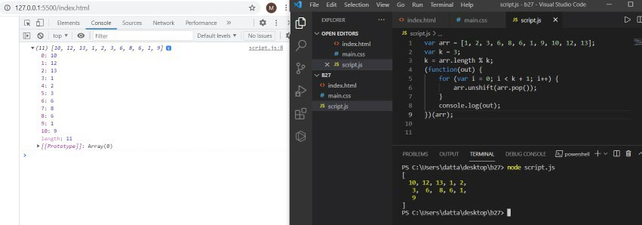

1. **Fix the code to gen Title case. # All first letters in Title case**

var arr = ["guvi", "geek", "zen", "fullstack"]; (function() {

for (var i = 0; i < arr.length; i++) { console.log(arr[i][0].toUpperCase()+arr[i].substr(1));

**}**

**})();**

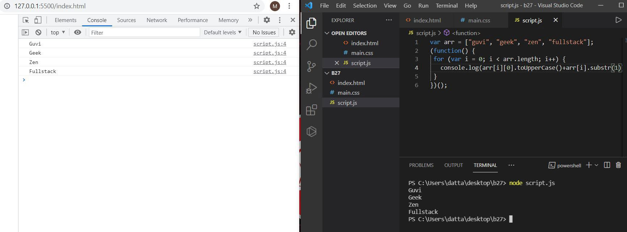

1. **print all odd numbers in an array using IIFE function var arr = [1, 2, 3, 5, 7, 79, 7, 2, 6, 9, 4];**

(function() {

for (var i = 0; i < arr.length; i++) { if (arr[i] % 2 !== 0) {

console.log(arr[i]);

**}}**

**})();**

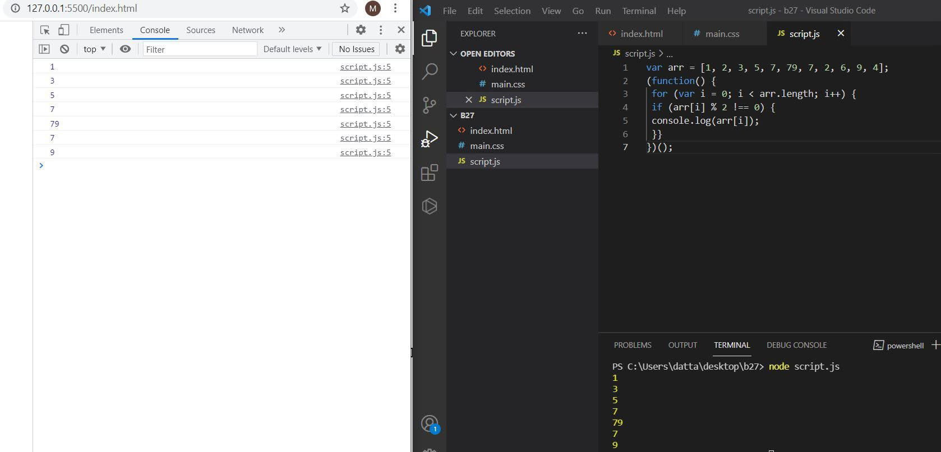

1. **Fix the code to reverse.**

(function(str){ var letters = [];

letters = str.match(/\S+/g); var str1 = "";

for (var i = 0; i < letters.length; i++) {

str1 += letters[i].split('').reverse().join('') + " ";

**}**

console.log(str1);

})("abcd");

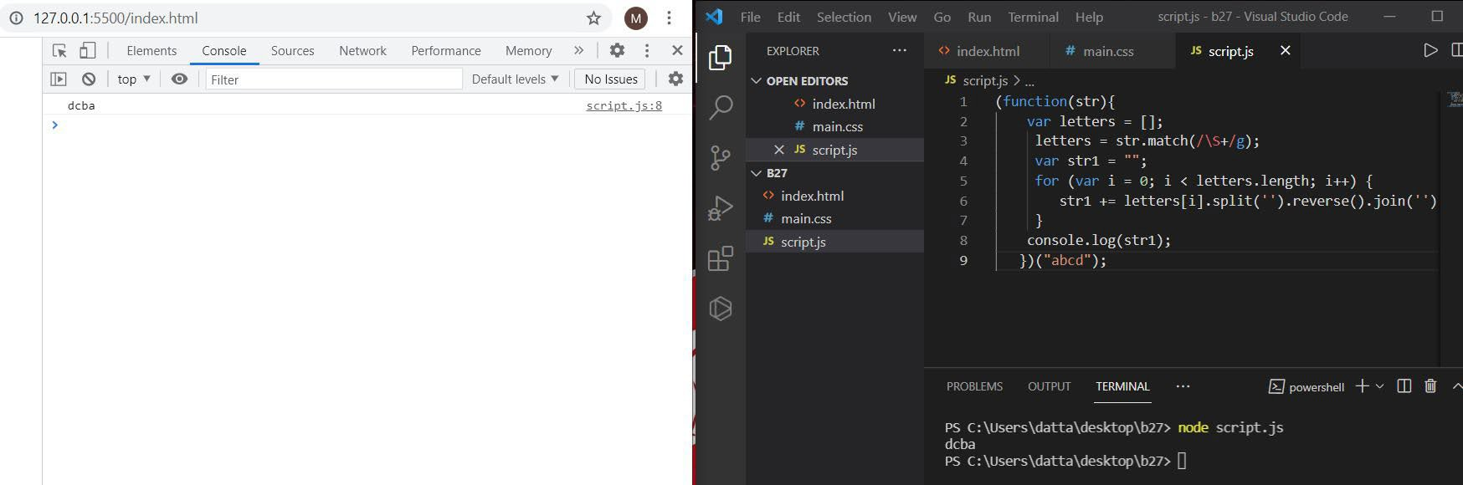

1. **Fix the code to remove duplicates.**

var res = function(arr){ var newArr = [];

for(var i=0; i < arr.length; i++){ if(newArr.indexOf(arr[i]) === -1) {

newArr.push(arr[i]);

**}**

**}**

console.log(newArr);

**};**

res(["guvi","geek","guvi","duplicate","geeK"]);

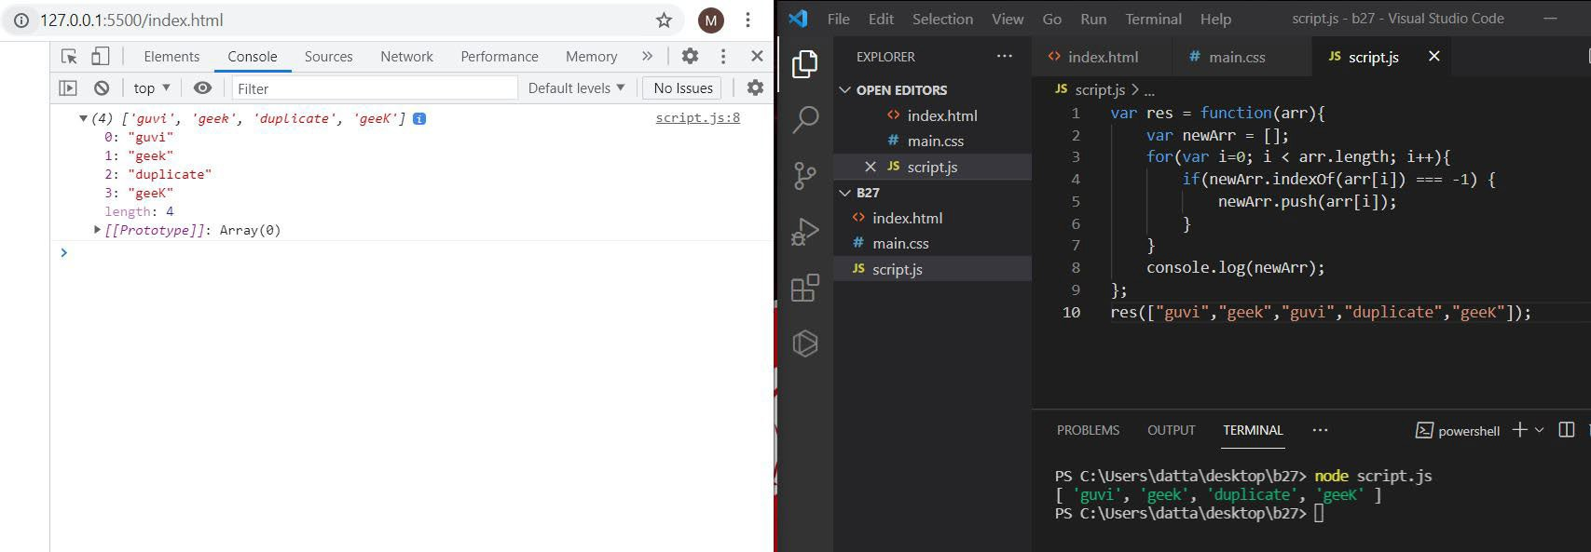

1. **Fix the code to give the below output:**

Expected Output:

**[**

{firstName: “Vasanth”, lastName: “Raja”, age: 24, role: “JSWizard”},

{firstName: “Sri”, lastName: “Devi”, age: 28, role: “Coder”}

**]**

var array

=[[["firstname","vasanth"],["lastname","Raje"],["age",24],["role","JSWiza

rd"]],[["firstname","Sri"],["lastname","Devi"],["age",28],["role", "Coder"]]];

var final=[]; while(array.length!==0)

**{**

var outer_remove = array.shift(); var new_object = {}; while(outer_remove.length!==0)

**{**

var inner_remove = outer_remove.shift(); var key = inner_remove[0];

var value =inner_remove[1]; new_object[key]=value;

**}**

final.push(new_object);

**}**

console.log(final);

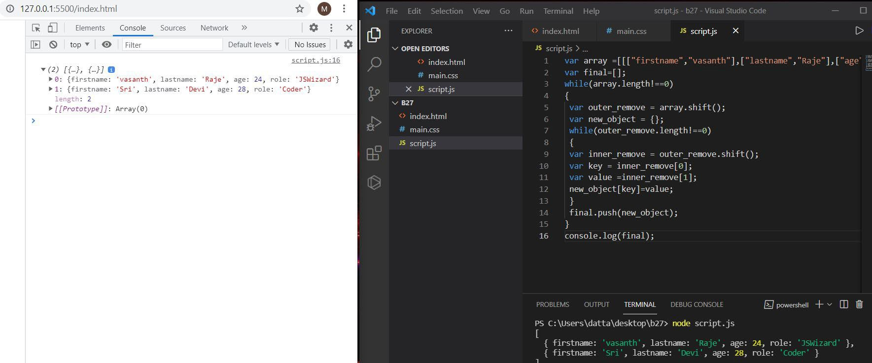

1. **Fix the code to give the below output Sum of odd numbers in an array**

let as=[12,34,5,6,2,56,6,2,1];

let s=as.reduce(function(a,c,i){ if (i === 1){

if(a%2!==0){

if(c%2!==0){

return a+c;

} return a;

}return 0;

}else if (c%2!==0){ return a+c;

}return a;

**});**

console.log(s);

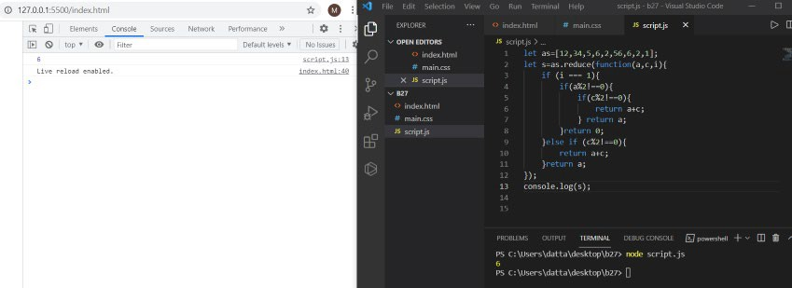

1. **Fix the code to give the below output:**

Swap the odd and even digits

let aa = data=>{ var a=data;

var l='';

for(let i=0;i<a.length-1;i++){

//var l=''; var s=a[i+1]; var b=a[i]; l+=s;

l+=b; i=i+1;

**}**

if((a.length%2)!==0){ l+=a[a.length-1];

**}**

console.log(l);

**};**

aa("1234");

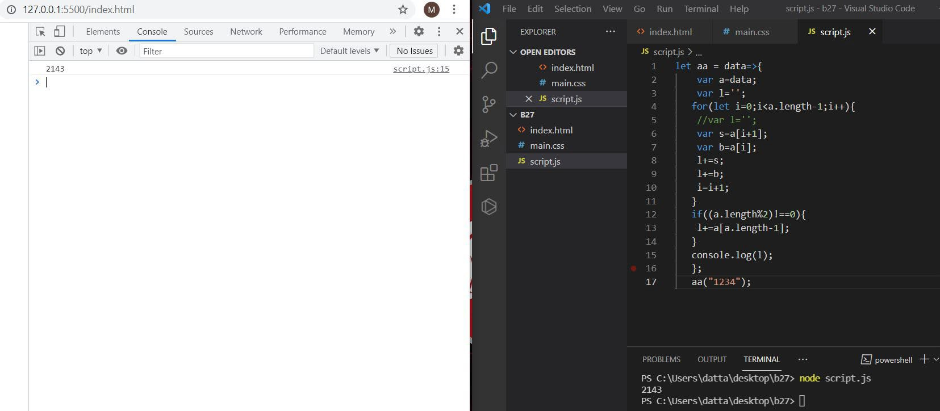

// Submitted by Jagadeesh Kumar . S